1. Total revenue

select sum(total_price) Total_revenue from pizza_sales;

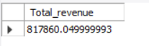

1. Average order value

select sum(total_price)/count(distinct(order_id)) Total_revenue from pizza_sales;



1. Total Pizza sold

select sum(quantity) Total_pizza_sold from pizza_sales;

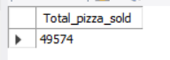

1. Total orders

select count(distinct(order_id)) as Total_orders from pizza_sales;

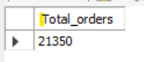

5.Average pizzas per order

select sum(quantity)/count(distinct(order_id)) average_pizzas_per_order from pizza_sales;



6. Order count aggregration by weekday

select dayname(order_date) as order_day, count(distinct(order_id)) as total_users

from pizza_sales

group by order_day

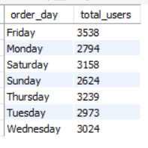

7. Month wise aggregation

select monthname(order_date) as Month_Name, count(distinct(order_id)) as total_users

from pizza_sales

group by Month_Name;

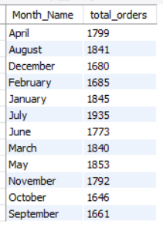

8. % contribution of each pizza category to sales

select pizza_category, round(sum(total_price)*100/(select sum(total_price) from pizza_sales),2) as pct_Total_sales from pizza_sales

group by pizza_category;

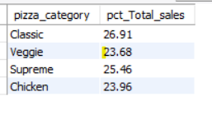

9. % contribution of each pizza size to sales

select pizza_size, sum(total_price),round(sum(total_price)*100/(select sum(total_price) from pizza_sales),2) as pct_Total_sales from pizza_sales

group by pizza_category;

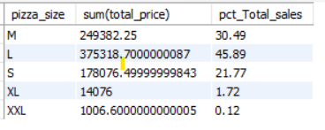

10. Top 5 pizza by revenue

select pizza_name, sum(total_price) as total_revenue from pizza_sales

group by pizza_name

order by total_revenue desc limit 5;

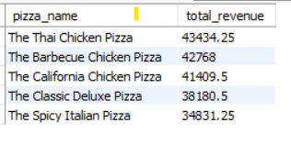

Bottom 5 by pizza name

select pizza_name, sum(total_price) as total_revenue from pizza_sales

group by pizza_name

order by total_revenue limit 5;

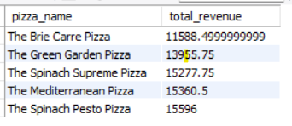

11.